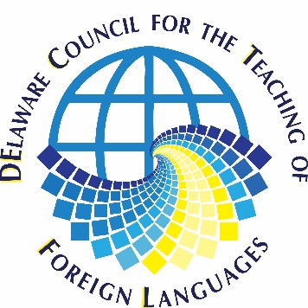
Membership Application Form
208 North Road, Wilmington, DE 19809
Regardless of method of payment please complete this form.
One year - $35.00 Two year - $65 Three year - $90

Name:
Home Address:
City: State: Zip:
Personal E-mail address: ________________________________________________________
Personal phone number:
Work phone number:
School Name (Institution) and District:
School Address:
Work E-Mail: __________________________________________________________________
City: State: Zip:
Language(s) taught:

Method of Payment: Check: payable to DECTFL
Check online payment

