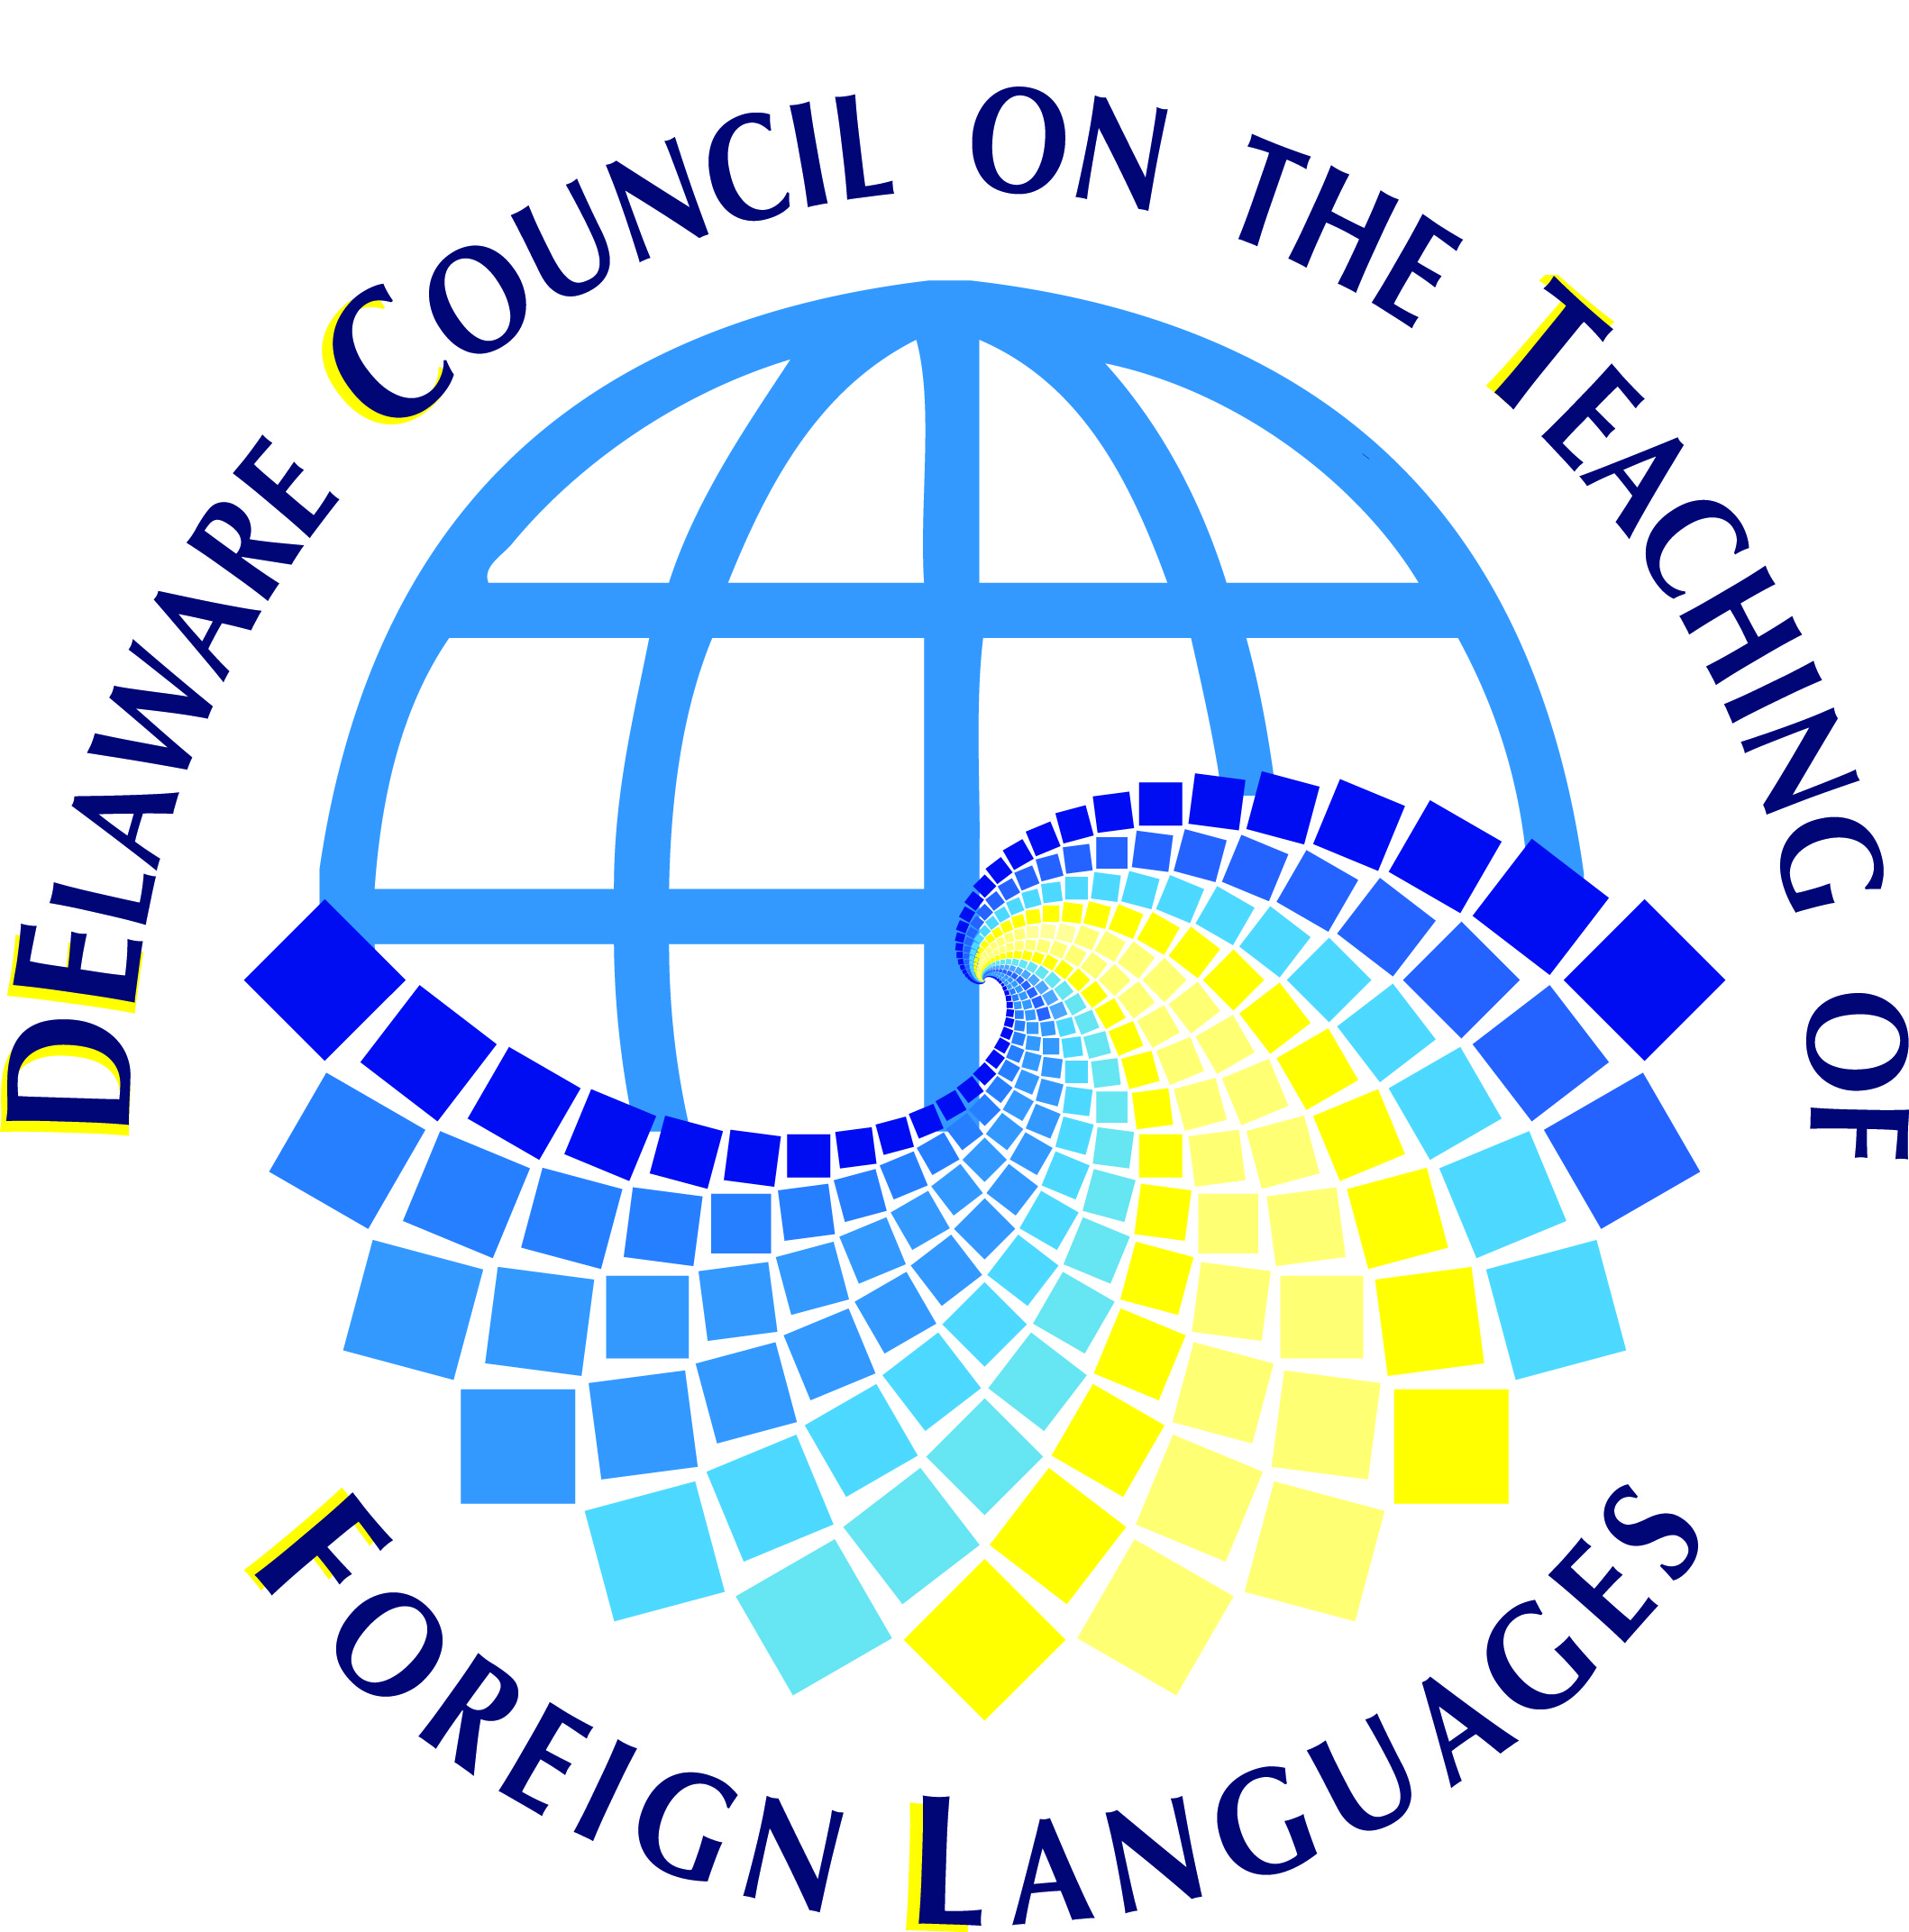

DECTFL 2013-2014
World Language Advocate of the Year Nomination Form

What is the Purpose?
The purpose is to honor and demonstrate appreciation to someone other than a classroom teacher. It may be an administrator, a legislator, a journalist, a parent and so on, who has supported and promoted the cause of World Languages in Delaware.

Who is eligible?
The nominee must be a member of the Delaware community who has made contributions above and beyond the call of duty by directly or indirectly advocating for World Language education, awareness, and dissemination.

Who can nominate a World Language Advocate?

Anyone can make a nomination. An individual may nominate only one person for the award. Nominations may include up to four letters of support. These letters should describe the attributes that your nominee possesses that make him/her an outstanding world language advocate.

What are the criteria for selecting the Advocate of the Year?

A panel of judges who are DECTFL members will review the nominations and select the award recipient(s). The nominee must be person who:

- Has made a positive impact on the Delaware World Language Community
- Spreads positive understanding of linguistic minorities
- Promotes acceptance of different languages and cultures
- Has demonstrated participation and leadership in the Delaware World Language Community
- Has fostered cooperative relationships in the Delaware World Language Community

Awards and Recognition

The Advocate of the Year will be announced at the DECTFL Annual Dinner Meeting.

Deadline for nominations:
Friday, October 11, 2013
Questions and submissions:
Debbie Supplee
Nominations Committee Chairperson
John Dickinson HS Wilmington DE
(302) 992-5500 ext. 207
debbie.supplee@redclay.k12.de.us

