LILL Description
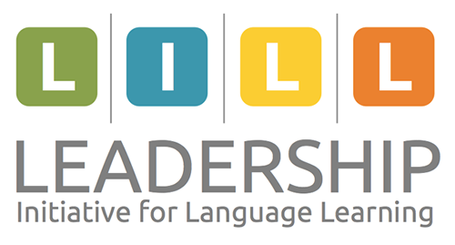
June 27-29, 2017
Niles North High School
Skokie, IL (Chicago Area)

DECTFL is looking for an EMERGING LEADER
- Language educators (Pre-K through Postsecondary)
  - A leader who demonstrates the following characteristics:
  - Energy, positivity, and a growth mindset (in plans, projects, or tasks)
  - Self-confident, self-starter and self-motivator
  - Commitment to and ownership in the organization
  - Potential to expand one’s sphere of influence outward
  - Risk-taker interested in growing in expected and unexpected ways
  - Grit and perseverance when confronted with an obstacle, problem, or issue
  - Creativity, new perspectives, and innovation in developing solutions

(please see Application for commitment requirements)

WHAT IS LILL?
The Leadership Initiative for Language Learning (LILL) seeks to:
- empower individuals to become agents for change,
- foster a growth mindset focused on effective teaching and learning, and
- purposefully nurture leadership skills, all in the service of learners.
LILL’s summer initiative is based on the premise that every educator is a leader and strives to be highly effective. For language educators, effectiveness is demonstrated by evidence of learners’ growth in proficiency, including their growth in interculturality. This initiative aims to bring the best and brightest language educators, teacher leaders, and national experts to explore this issue and others important to you and the language organization naming you as an Emerging Leader. As an Emerging Leader, you will have the opportunity to discover your sphere of influence for effecting change, engage with peers, and create your own proactive plan to grow in your effectiveness as a leader and language teacher.

WHY EXPERIENCE THE LILL SUMMER INSTITUTE?

SHARE AND LEARN
Interact with emerging leaders and “veteran” leaders.
Engage with teacher presenters as they share their ideas and lead discussions.
Focus on your organization’s area(s) of interest to celebrate successes and discover new strategies for improvement.

PRACTICE AND GROW
Examine leadership strategies.
Collaborate in small and large groups.
Determine ways to apply these strategies in emerging leadership roles.

PLAN AND ACT
Create your personal plan to support your organization’s goal(s).
Identify your leadership spheres of influence and design ways to share your learning.
Share your plan with other participants and use their feedback to refine your plan.

INTERESTED IN ATTENDING?
- You must be a DECTFL member.
- You must complete the application and agree to the yearly commitment
- You must agree to pay the remaining portion of costs that are not covered by DECTFL.

WHEN AND WHERE?

WHEN
- June 27-29, 2017
  - Arrive by noon on Tuesday, June 27
  - LILL Summer Institute runs through Thursday, June 29, 3:00 PM

WHERE
- Niles North High School, 9800 Lawler Avenue, Skokie, IL
- Website and Directions: http://www.niles-hs.k12.il.us/north/contact-us-directory
- 30 minutes from O’Hare International Airport (Chicago – ORD)

COST AND REGISTRATION

KNOW BEFORE YOU GO!
The institute fee ($200) sustains our work and includes: (Covered by DECTFL)
- All institute materials and on-site presenters
- Lunch and snack breaks (June 27, 28, and 29)
- Dinner on June 27
These expenses are NOT included in the institute fee and are your responsibility:
- Lodging for 2 nights (covered by DECTFL)
  - Breakfasts included
  - 5-minute walk from the institute
- Dinner on June 28
- Airfare (covered by DECTFL)
- Driving costs to and from the institute
- Pre-Institute Book Study (TBD, est. $20-50)

